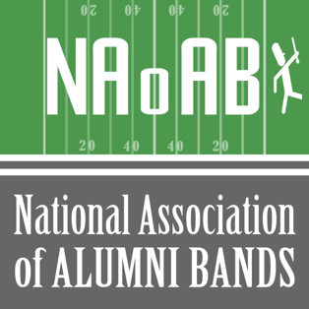
Ideas and Suggestions for Alumni Bands
Success Stories
AlumniBands.Org | @AlumniBands | info@AlumniBands.Org

Category: [ORGANIZING Reunions, uniforms, bylaws, …]
Interest Grabbing Title: [“The Good, Bad and the Musical”]

CONTRIBUTOR
[Photo here]
Name of Contributor: [Name here]
Member Organization: [Alumni Band Organization Name]
Email: [Your Email Here]
Background: [Your time or position in the organization, when organization started, how active, how many alumni band members, …]

INTRODUCTION TO ISSUE Covered IN THIS STORY
[What Is The Alumni Band Organizational Challenge Being Covered In This Article?]

THE CHALLENGES
[What was holding back success for the organization?
- Education for other parts of the university
- Lack of experience for some volunteers]

THE OPTIONS CONSIDERED FOR A SOLUTION
[What was the plan? How did you organize the team? How did you staff the team?
Were volunteers the right mix? Was there enough time? Any deadlines?]

THE OPTION TAKEN and reasons why
[What this choice and would you recommend that option to others?
- Committee execution
- Outsourced the activity
- NaoAB Mentor involved? Heard at Virtual Roundtable? Experienced at Symposium?]

THE RESULTS
[What were the quantifiable successes?]
[What were the non-quantifiable successes – resulting team, friendships, new members?]

THE COSTS Involved
[Calculations here?]

WOULD You recommend this option TO others
[For the option chosen, would you recommend that option to others?
- Why recommend this, or another option?
- Why not recommend this option?]

Lessons Learned
- [What would you do differently?]
- [What would you change?]

WHY THIS TOPIC IS OF INTEREST FOR A VIRTUAL ROUNDTABLE
- [Universal interest]
- [Of interest due to the uncertainty brought by the current pandemic situation]
- [Never been done before.]

